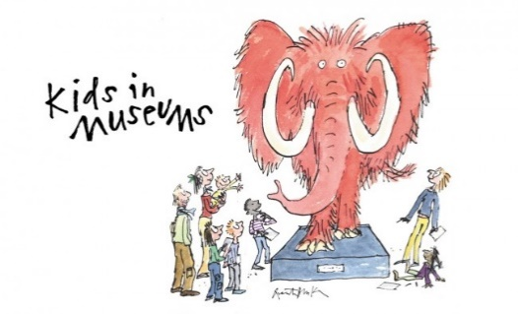
Takeover Day 2019
Photo Permission Form

In this consent form we are asking for your permission to take, store and use images or video of your child taken on Takeover Day.
We would like to share these images to show the achievements and benefits of taking part in Takeover Day. This includes sharing the images with Kids in Museums, the organisation that runs Takeover Day.
[INSERT SCHOOL/ORG NAME] and Kids in Museums may use the images for the following purposes:
- On their social media (Twitter, Facebook, Instagram and LinkedIn)
- On their websites (www.kidsinmuseums.org.uk)
- In the press
- In printed and online marketing materials
- To share with any funders to illustrate the work of Kids in Museums – only if they have suitable data protection and privacy policies in place.
We confirm that on receipt of the images, [INSERT SCHOOL/ORG NAME] and Kids in Museums will do the following:
- Store the images securely and retain them for a maximum of five years.
- Only use them for the purposes outlined above. If we wish to use them for any other purpose, we will seek your permission.
- Share them with your organisation on request.
- Caption any images used appropriately so as not to directly identify any of the children and young people shown (we will only use first names if any in captions).
- Delete the images immediately if you notify us that consent has been withdrawn by any of the children and young people depicted.
I,
[INSERT YOUR FULL NAME]

give [INSERT SCHOOL/ORG NAME] and Kids in Museums permission to use the image of:
[INSERT NAME OF CHILD]

in the ways outlined above. I understand that I can withdraw my consent at any time.
Date

