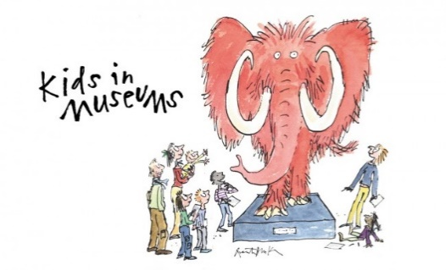
Takeover Day 2019
Photo Permission Form

Thank you for sharing images from your Takeover Day with Kids in Museums.
Kids in Museums may use the images taken at the event on social media (Twitter, Facebook, Instagram and LinkedIn), on our website (www.kidsinmuseums.org.uk), for press and in other printed and online marketing materials. We may also share the images with our funders to illustrate our work if they have suitable data protection and privacy policies in place.
We confirm that on receipt of the images, Kids in Museums will do the following:
- Store the images securely and retain them for a maximum of five years.
- Only use them for the purposes outlined above. If we wish to use them for any other purpose, we will seek your permission.
- Share them with your organisation on request.
- Caption any images used appropriately so as not to directly identify any of the children and young people shown (we will only use first names if any in captions).
- Delete the images immediately if you notify us that consent has been withdrawn by any of the children and young people depicted.
Please sign the form below to confirm the following:
- Your organisation, [INSERT NAME], has obtained appropriate consent for the children and young people participating on Takeover Day on [INSERT DATE].

- Your organisation is happy for Kids in Museums to use and store the photographs as outlined above.

- Your organisation will notify Kids in Museums if the photo consent is withdrawn from any of the children and young people who are in the photographs.

Signed on behalf of [INSERT NAME]

Date

